

**Trimester: I/II/III Subject: Programming and Problem Solving**

**Name**: Krishnaraj Thadesar **Division:** 9

**Roll No.:** 109054 **Batch:** I3

**Experiment No.:** 2A

**Name of the Experiment:** Write an algorithm and draw a flowchart to find the roots of quadratic equation

**Performed on:** 16nd December 2021

**Submitted on:** 23rd December 2021

**AIM:** Write an algorithm and draw a flowchart to find the roots of quadratic equation

**OBJECTIVES:**

1. To learn design and development of algorithm.
2. To understand importance of flowchart for any programming model.
3. To learn simple flowchart symbols and arrows to define relationships.
4. Solve a quadratic equation with real coefficients by factorization and by using quadratic formula

**THEORY:**

1. Concept of Quadratic Equation

A quadratic equation is an [algebraic expression](https://www.cuemath.com/algebra/algebraic-expression/) of the second degree in x. The [quadratic equation in its standard form](https://www.cuemath.com/algebra/standard-form-of-quadratic-equation/) is ax2 + bx + c = 0, where a, b are the coefficients, x is the variable, and c is the constant term. The first condition for an equation to be a quadratic equation is the [coefficient](https://www.cuemath.com/algebra/coefficient/) of x2 is a non-zero term(a ≠0). For writing a quadratic equation in standard form, the x2term is written first, followed by the x term, and finally, the constant term is written. The numeric values of a, b, c are generally not written as fractions or decimals but are written as integral values.

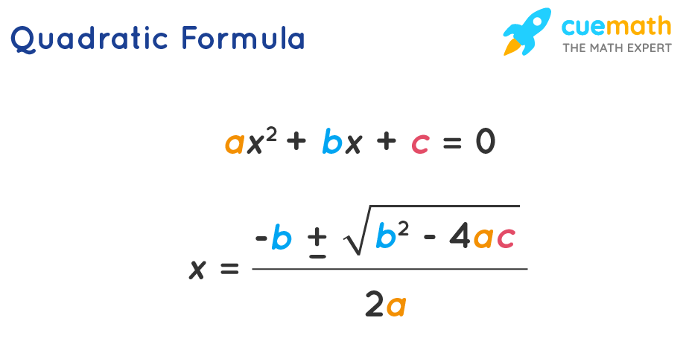

1. Algorithm

A finite set of steps that must be followed to solve any problem is called an algorithm. Algorithm is generally developed before the actual coding is done. It is written using English like language so that it is easily understandable even by non-programmers.

1. Flowchart

A flowchart is a diagram that represents a set of instructions. Flowcharts normally use standard symbols to represent the different types of instructions. These symbols are used to construct the flowchart and show the step-by-step solution to the problem.

1. Pseudocode

In computer science, pseudocode is a plain language description of the steps in an algorithm or another system. Pseudocode often uses structural conventions of a normal programming language, but is intended for human reading rather than machine reading. It typically omits details that are essential for machine understanding of the algorithm, such as variable declarations and language-specific code.

# PLATFORM: 64 Bit Windows 11

**INPUT:** Give any 3 coefficients

**OUTPUT:** Roots of quadratic equation of nature real and imaginary

Algorithm:

Step 1: Start

Step 2: Declare the Variables root_1, root_2, a, b, c, det = 0 as floats

Step 3: Print "Enter the values of A B C"

Step 4: Input the values of A, B, C and assign them to a, b, c

Step 5: Calculate the Determinant and assign it to det as det = sqrt(b*b -(4 * a * c))

Step 6: Calculate the first root as: root_1 = (-b + det)/(2 * a)d

Step 7: Calculate the second root as: root_1 = (-b - det)/(2 * a)ḍ

Step 8: Print the Values

Pseudo Code:

int main(){

float root_1, root_2, a, b, c, det;

print("Enter the values of A, B and C")

input(a, b, c)

det = sqrt(b*b -(4 * a * c))

root_1 = (-b + det)/(2 * a)ḍ

root_1 = (-b - det)/(2 * a)ḍ

print("The First root is", root_1)

print("The Second root is", root_2)

}

Flow Chart:

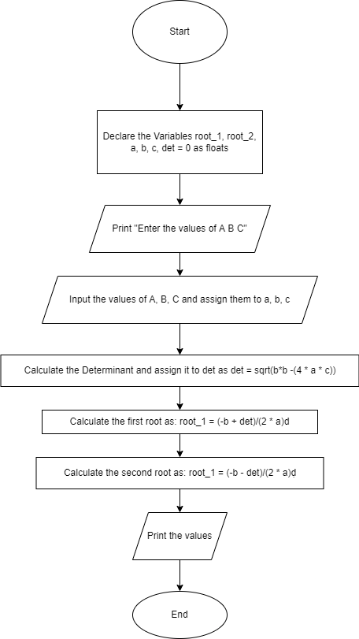

**CONCLUSION:** Thus we have learned to draw algorithm and flowchart for how to compute roots for quadratic equation

**FAQs:**

1. What are different types of equations? How to calculate roots of quadratic equation?

**1. Linear Equation:**

A linear equation is an algebraic equation. In linear equation, each term is either a constant or the product of a constant and a single variable. If there are two variables, the graph of linear equation is a straight line.

General form of the linear equation with two variables is given below:-

y = mx + c, m ≠ 0.

**2.Polynomial Equation:**

Polynomial Equation can be expressed in terms of monomial, binomial, trinomial and higher order polynomials. It may contain on both positive and negative values. Polynomials may also contains on decimal values.

3x3– 3 + 2x = 0

**3. Quadratic Equation:**

It is the second degree equation in which one variable contains the variable with an exponent of 2. Its general form is

ax2 + bx + c = 0, a ≠ 0

**4. Trigonometric equation:**

These equations contains a trigonometric function. So, first we must have to introduce the trigonometric functions to explore them thoroughly. Only few simple trigonometric equations can be solved without any use of calculator but not at all. In some cases, inverse trigonometric functions are valuable.

**5. Radical Equation:**

It is an equation whose maximum exponent on the variable is 1/2 and have more than one term or a radical equation is an equation in which the variable is lying inside a radical symbol usually in a square root.

**Quadratic Formula** is the simplest way to find the roots of a quadratic equation. There are certain quadratic equations that cannot be easily factorized, and here we can conveniently use this quadratic formula to find the roots in the quickest possible way. The roots of the quadratic equation further help to find the sum of the roots and the product of the roots of the quadratic equation. The two roots in the quadratic formula are presented as a single expression. The positive sign and the negative sign can be alternatively used to obtain the two distinct roots of the equation.

Quadratic Formula = [-b ± √(b² - 4ac)]/2a



2. Write an algorithm and draw a flow chart to perform arithmetic operations on 2 numbers.